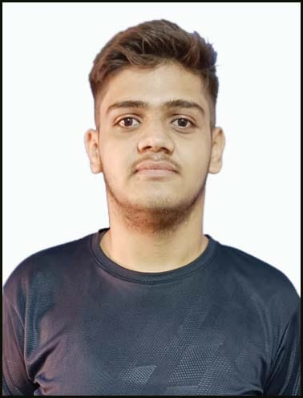
Registration Number: 22BCE11038
Email: utsavjha3810@gmail.com
Phone: +91 620070051
linkedin.com/in/utsavjha2004
https://github.com/Utsav-Jha-2004

Utsav Jha
Technical Skills: C/C++, Python, HTML/CSS
EDUCATION
Board | Tenure | Educational institution | CGPA/Percentage
B. Tech (CSE)  Gaming | Oct 22 –Ongoing | VIT Bhopal University, M.P. | 8.6
Class XII | May 22 | Public School Darbhanga | 83
Class X | May 20 | Delhi Public School Kadirabad, Darbhanga | 90.6

CO-CURRICULARS
Coding | - Hackerrank 3 Star in C++. Leetcode – Global Rank - 900000

ADDITIONAL INFORMATION
Hobbies | - Watching Movies, Web serieses, animes.  - Reading novels, comics & mangas  - Playing chess
Languages | - English, Hindi

